Fiscal Decentralization in Jordan:
Reframing the debate and discussing the parameters of an intergovernmental transfer formula for Governorates

Summary
Decentralization has been on the Government of Jordan’s agenda for more than fifteen years. However, a close examination of the political discourse reveals three features that warrant further analysis. First, there is no clear distinction between the political, fiscal and administrative aspects of decentralization and the sequence by which they should occur. Second, more emphasis has been paid to aspects of administrative decentralization, rather than to the transfer of political power and financial resources from the central government to governorates needed to increase transparency and accountability, as well as the autonomy and capacity of subnational governments. Third, the little that has been written about the autonomy of governorates does not adequately consider the need for an intergovernmental transfer system to allocate national revenues to subnational governments. Drawing from fiscal decentralization experiences in other countries, and from the specific historical and institutional context of Jordan, this article constitutes the first attempt to model capital transfers and to discuss the parameters of an intergovernmental transfer formula. The results show that a more comprehensive and appropriately structured mix of transfer decision criteria can help mitigate the ambiguity of Jordan’s transfer policy. This includes changing the weights of some current transfer criteria and factoring in new ones.

Keywords: Development, Public Administration, Local Governance, Fiscal Decentralization, Formula-based Transfers, Jordan

1. Historical Context and Policy Gap
In his 2005 Address to the Nation, King Abdullah II of Jordan stressed the importance of economic, social and administrative development occurring hand-in-hand with forms of “political development” that enable both (i) greater public participation in public sector policymaking and implementation, and (ii) effective social auditing of public sector performance. In his own words, King Abdullah II is driven by a “[…] keenness to have people in their respective governorates participate in affairs related to public facilities, investment priorities, expenditures on capital and service projects and in overseeing the performance of official bodies in all areas […].”

In the past few years, the Government of Jordan has increased its efforts towards decentralization. The formation of the Royal Commission of the Regions in 2005 was a major step in this direction (Regionalization draft law, 2005). The main goals of this plan were (i) to administratively divide the country into three regions (i.e., North, Middle, and South), and (ii) to create regional elected councils (with members from each governorate) responsible for local development. The regional councils would operate as an intermediate administrative level between the central government and the governorates.

In February of 2008, the Prime Minister ordered the transfer of 92 specific functions from the central ministries to their representatives at the governorate level (UNDP 2009). The intended result of deconcentrating authority and resources was to make services more accessible and service delivery more efficient at the governorate level.

In October of 2008, the King stated, “participation in decision-making and implementation, especially in the governorates, requires envisioning a local administrative system that tends to be decentralized and that guarantees quick and efficient implementation.” He added, “reactivating local government administration is the best means to expand the basis of public participation and to foster political, social and economic development” and “our vision for social and economic development goes hand-in-hand with our vision for political development which aims at expanding participation in decision-making and implementation, and at anchoring the principles of participation and accountability and equal opportunities.”

In 2010, the Local Council Law allowed the creation of local and executive councils at the governorate level, in addition to the existing municipal councils (MOI 2010). According to this law, local councils are composed of thirty members, of which twenty are elected (with a 20% quota of women) and ten are appointed by the Prime Minister upon the governor’s recommendation. Executive councils are composed of line ministry directors at the governorate level, in addition to three municipal executive directors. All members of the municipal councils are elected (with a 20% quota of women).

In 2011, the Municipal Law (13/2011) introduced two key reforms for decentralization and participation at the local level (MOMA 2011). First, under this new law, the total number of municipal councilors (including Mayors) has to meet a 25% quota of women. Second, this law defines a framework for both the financial autonomy of municipalities, as well as the involvement of the private sector and civil society in local development.

The Government of Jordan is currently developing Governorates Development Strategies (GDS) for each of the governorates in the country. The GDS is an action-framework that includes all of the priority projects that use participatory approaches and analyses of the socioeconomic indicators, services and infrastructures at the governorate level. In addition, dozens of other studies and policy documents have been prepared for the decentralization initiative by the Government of Jordan, international agencies, and by scholars. Neither the GDS, nor any studies or policy papers, ever explicitly formulate a financial transfer system, let alone a concrete formula, for allocating national revenues to the governorate level (UNDP 2009; LGDK 2008, 2011; MOPIC 2010).

Transfers from the national to the municipal levels follow a formula that was established in 2005, which is currently being reviewed (MOMA 2010). Article 51 of Municipal Law No. 13/2011 specifies general factors that must be considered by the government in distributing national revenues among municipalities (MOMA 2011). The formula aims to (i) achieve equity in accessing government services, (ii) reduce the financial differences between the various municipalities, and (iii) improve the performance of municipalities. A similar formula or legal framework for governorates does not exist.

The formula for municipalities includes eleven variables (formula weights are shown in parenthesis):
- Population (20%)
- Area share (10%)
- Annual expenditure per capita (20%)
- Revenue collection percentage (2%)
- Savings or debt (15%)
- Income growth rate (5%)
- Governorate administrative center (5%)
- Income shortfall (2.5%)
- Expenditure shortfall (2.5%)
- Number of regions (15%)
- Deviation of capital expenditure (3%)

Table 1 shows the evolution of transfer amounts between 2002 and 2009. During this period, the total transferred from the central government to municipalities was between 0.5%-0.66% of the GDP.

Table 1: Transfers from the central government to municipalities
 | 2002 | 2003 | 2004 | 2005 | 2006 | 2007 | 2008 | 2009
Total Transfers  (thousands of JD) | 20,655 | 34,313 | 34,214 | 44,160 | 51,571 | 53,101 | 74,368 | 74,368
Source: Jordan Resource Transfer Pool and Allocation to Municipalities Bulletin No. (01)

By international standards, these are very low figures. According to the IMF’s GFS Yearbook 2008 the ratio of transfers to total government spending in Jordan was 3.3% in 2009. The average for 61 countries studied was 17.8%. The disparity is even larger if the comparison is made with the proportion of these transfers to central government spending: 1.4% in Jordan against 10.7% for the same group of 61 countries.

Municipal funds come from three sources: (i) local taxes and service fees (i.e., property taxes; sanitary and municipal violation fees); (ii) transfers from the State (the sum of 6% of the tax on refined petroleum products, 40% of the tax on the purchase of vehicles, and the proceeds of road traffic fines); and (iii) loans from the Cities and Villages Development Bank (CVDB).

2. Local Government System
2.1. Governorates
As previously noted, governorates are deconcentrated entities of the central government. There are a total of twelve governorates managed by appointed governors and line ministry directors that, jointly with mayors, form the executive council. In addition, the local council has advisory and consultative functions and is comprised of representatives of civil society institutions, municipalities, members of Parliament and State representatives.

The governor is appointed by the Council of the Ministers on the recommendation of the Minister of Interior. As such, he assumes the highest executive authority in the governorate, and his primary role is to maintain law and security. In addition, he coordinates and monitors the performance of government agencies in the governorate, promotes an investment and development-friendly environment (without any direct implementation role), and supervises local councils’ activities.

The line ministries and other central government agencies function at the sub-national level through their respective governorate‐based directorates. These deconcentrated units may vary in the authority and responsibility delegated to them by their parent ministries, though overall, the key decisions and implementation responsibilities remain with the ministries’ central administration.
An executive council, chaired by the governor, is established in each governorate, and is comprised of the heads of the line ministries’ directorates. The executive council is vested with the tasks of coordinating plans, programs and activities of the line ministries at the governorate level. The council has, however, no executive power since most of the important decisions (e.g., planning, program design and budgeting) are made at the central level.

Each governorate also has an advisory local council that is chaired by the governor and is made up of 25 members selected from the following individuals: Parliament members from the concerned governorate, mayors of municipalities, private sector organizations, and civil society. The council’s role is limited to raising proposals to the executive council and the governor, especially in respect to the annual governorate’s budget(s). The advisory council provides, however, a measure of popular participation in the administration of governorate affairs.

2.2. Municipalities
Municipalities are genuine, decentralized local government administrations, in that they have policy-making, administrative and fiscal autonomy pursuant to the provisions of Law No. 14 (2007). Indeed, Article 3 asserts that the “municipality is a local institution vested with financial autonomy,” while legal authority is vested in the municipal council.

Municipalities are classified into 4 categories depending on their location and population size. As a result of an amalgamation process started in 2001, the number of municipalities in Jordan has decreased from 328 to 93 (see Table 2).

Table 2: Number of Municipalities by Governorate
Region | Governorate | Num. of Municipalities | % Urban Population
North | Irbid | 18 | 82.9%
 | Mafraq | 18 | 39.2%
 | Jarash | 5 | 62.6%
 | Ajloun | 5 | 75.9%
Middle | Amman | 2 | 94.0%
 | Balqa | 9 | 71.8%
 | Zarqa | 7 | 94.5%
 | Madaba | 4 | 71.4%
South | Karak | 10 | 35.0%
 | Tafilah | 4 | 71.4%
 | Ma'an | 7 | 54.9%
 | Aqaba | 4 | 86.0%
Jordan | TOTAL | 93 | 82.6%
Sources: Ministry of Municipal Affairs (MOMA)

The governance structure of the municipality has two bodies: the municipal council and the Mayor’s administration. The municipal council is the policy-making branch responsible for formulating the local development vision and for adopting the municipality’s strategic plans and annual budgets. The council members and the mayor are directly elected by the local constituency, with the exception of the Greater Amman Municipality, where the mayor and half of the council members are appointed by the central government and the other half is directly elected by the citizens. The mayor chairs the municipal council and acts as the chief executive officer (CEO) of the municipality. As such, he has full authority over the municipal administration, with the assistance of the municipality manager. The latter is appointed by the Minister of Municipal Affairs (MOMA) upon recommendation by the respective municipal council.

Law No. 14 assigns 29 specific functions to the municipal council, of which 26 relate to urban service delivery (see Appendix 1) and a general-purpose mandate that authorizes the council to carry out developmental activities that benefit the municipal constituency (Article 40, Paragraph (j) of the Municipality Law). However, in practice, not all municipalities are in a position to assume each of their assigned functions in a consistent and effective manner because of (i) limited financial resources (be it their own source revenues or central government transfers), and (ii) weak administrative and technical capacity.

The Ministry of Municipal Affairs is the supervising authority of the municipal sector; as such the Ministry is responsible for (i) supporting the municipalities (i.e., local capacity development, technical advice); (ii) monitoring the regularity of key acts of the municipal council (i.e., approval of plans and budgets, setting rates and bases of local fees and charges, approval of municipal borrowing); and (iii) authorizing the formation of joint service councils by two or more municipalities.

2.3. Relationship between Central Government, Governorates and Municipalities
According to current national regulations there is no clear-cut administrative and financial relationship between governorates and municipalities in Jordan. Although they are located within the geographic boundaries of governorates, municipalities are overseen, financially and administratively, by the Ministry of Municipal Affairs (MoMA). Governorates, on the other hand, are overseen by the Ministry of Interior (MOI). All administrative and financial decisions at the municipality level, including those related to the annual budget, have to be approved by MoMA. Figure 1 illustrates this governance structure.

Figure 1: Governance structure in Jordan
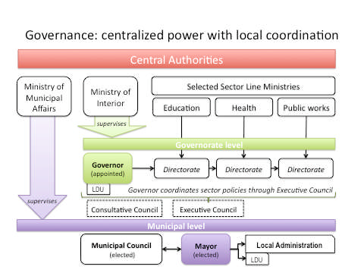
Source: SOFRECO (2010).

3. Fiscal Decentralization in Jordan: A Focus on Governorates
Falleti (2005) defines decentralization as a process, and argues that the sequencing of different types of decentralization (i.e., fiscal, administrative and political) “is a key determinant of the evolution of intergovernmental balance of power” (p. 327). More specifically, the sequential theory of decentralization posits that the highest degree of change in the intergovernmental balance of power occurs if political and fiscal decentralization occur prior to administrative decentralization.

The theory also predicts that a decentralization process driven mostly by prevailing national (as opposed to subnational) interests will most likely start with administrative decentralization. This is so because central authorities will postpone the devolution of political authority and fiscal resources to subnational governments. Political decentralization will occur first only if subnational interests drive the reforms. Fiscal decentralization will occur first if neither national nor subnational interests succeed in imposing their political power on the other (i.e., fiscal decentralization results from a compromise between national and subnational interests).

Currently, decentralization in Jordan is consistent with the type of centrally driven process—promoted by both national politicians and international organizations—that focuses on administrative decentralization (i.e., policies that transfer the administration and delivery of social services such as education, health, social welfare, or housing to subnational governments). Falleti’s theory suggests that this approach is likely to result in a relatively low change in the intergovernmental balance of power because to offload responsibilities without transferring the necessary fiscal resources strengthens the central government’s dominance over subnational governments. Under fiscal strain, subnational governors will not only tend to align more with the national executives, but will also lose legitimacy vis-à-vis their constituencies, who in turn will put less value on the decentralization process itself.

The lack of local technical capacity to organize and deliver social services could be seen as a possible explanation for the fact that political discourse in Jordan is so focused on administrative decentralization. After all, governorates need skilled public officers to serve their communities. However, this cannot be considered a valid argument since, according to the current governorate administrative structure, line ministry experts, based in the governorates, fulfill the requirement for “localized” technical capacity.

Two conclusions can be derived from this initial analysis. First, it is theoretically understandable that administrative decentralization became a political prerogative in Jordan. Second, if the stated aim of decentralization in Jordan is to foster political development, then public sector performance and greater popular participation in the sequencing of decentralization in Jordan has to be given greater attention.

Thus far this discussion has focused in broad terms on fiscal decentralization. The focus now turns to the more specific question of what parameters should drive the design of an intergovernmental transfer formula. This work fills an important gap since current political and academic discourse has failed to result in an adequate decision-making tool to govern fiscal transfers from the national to governorate level .

4. A Formula Within the Context of Fiscal Decentralization in Jordan
Fiscal decentralization can be driven by five fundamental types of political goals: (i) to close the fiscal gap between central and subnational governments; (ii) to equalize inter-regional differences in financial capacity and/or service delivery; (iii) to offset externalities to avoid under-spending on services where there are substantial across-regions benefits; (iv) to distribute taxes that are collected by the central government under the justification that its capacity to assess and collect taxes is greater than subnational governments; and (v) to fulfill other political objectives such as exchange of political support (Bahl 2000, Bird and Smart 2001).

Regardless of the specific political goal(s) driving fiscal decentralization, there are two key components that have to be considered when designing a transfer system: the vertical and the horizontal balances. The vertical balance refers to the size of the distributable, or grant, pool and their sources. The size can be determined in three different ways: (i) as a fixed proportion of central government revenues; (ii) on an ad-hoc basis; and (iii) on a cost-reimbursement basis. The horizontal balance refers to how to distribute the grant pool across subnational levels. There are typically four ways of doing it: (i) the derivation approach; (ii) the formula approach; (iii) the conditional grants approach; and (iv) the ad-hoc approach (Bahl 2000). This article focuses on the horizontal balance only.

Chart 1a: Chart 1b:

Chart 1c: Chart 1d:

Note: The Governorates of Amman, Zarqa and Aqaba are displayed in separated charts for better identification of transfer patterns given the disparities within the scale used to compare governorates.

As illustrated by the irregularity of transfers for capital expenditure to the governorate level between 2009 and 2011, both in absolute (see Charts 1a and 1c) and relative (see Charts 1b and 1d) terms, ad-hoc criteria seems to best describes current intergovernmental transfers in Jordan.
This assertion is reinforced by the fact that GDP has been steadily increasing since 2008, signifying that the irregularity of transfers cannot be explained by macroeconomic instability. Interviews with public officers also support this assertion. Intergovernmental transfers are typically decided by case-by-case evaluations of project proposals received by the central government from governorates, and the amounts are allocated more or less discretionarily depending on the size of the grant pool still available. Expenditures to address across-governorates interests are normally incurred directly by the central government. As Bird and Smart (2001) argue, “discretionary or negotiated transfers are clearly undesirable” (p. 20).

The irregularity in the historical patterns of transfers illustrated by Charts 1a-1d is precisely the problem this article aims to address. Bahl (2000) argues that “formulas are meant to remove judgment” (p. 12), and moreover they (i) bring transparency as they clarifies the “rules of the game”; (ii) are less subjected to political manipulation as they mitigate arbitrary decisions; (iii) set expectations and lead to less uncertainty on the part of the local government on the amounts they will receive, which then encourages better fiscal planning and effective budgeting; (iv) encourage the central government to think of local governments more strategically (i.e., makes it less likely for the central authorities to consider reduction in transfers as a way to offload national budget deficits); and (v) allow local officials to feel more in control of their budgets and more accountable to their voters for the level of services provided. Bird and Smart (2001) argue that “transfers should be as simple, comprehensible, and reliably predictable as possible” (p. 10). Transfer parameters with these attributes work as an information system, and “good information is essential to ensuring enhanced services ... regardless of the status of political democracy” (ibid).

4.1. Transfer Formula Parameters and the Experience of Other Countries
In general, formula-based intergovernmental transfers are of two types: conditional and/or non-conditional (Ma 1997). Conditional transfers require certain preconditions be met by local governments before they can receive funds, whereas unconditional transfers do not have preconditions. A formula’s design includes many factors, which can be grouped into two broad categories: local needs and local fiscal capacity (Ma 1997). While the first focuses on the demand side of populations, the second focuses on the supply side of public administration.

Martinez-Vazquez and Boex (2002) argue that an intergovernmental transfer formula should respect ten core principles:
- Equity: The formula is fair; municipalities receive their fair share to be able to fulfill the transfers’ objective;
- Simplicity: The formula includes few variables and simple calculations;
- Transparency: The formula is understandable for the users;
- Need-driven: The variables reflect demand for services and not the actual expenditure structure;
- Stability: Large changes in allocations from one year to the next will not take place unless an objective reason exists, such as a large change in one variable;
- Immunity to local manipulation: It is not possible to manipulate the data;
- Budget autonomy: The formula should not affect municipalities’ budget autonomy;
- Incentive neutrality: The formula does not create disincentives for municipalities (e.g., for revenue collection or responsible financial management);
- Existence of data: Reliable data exists which is updated and published regularly;
- Acceptance, independence of data source: The data supplier is accepted and independent.

Taxes are the main source of Jordan’s national budget and they are fully collected and managed by the central government. In 2009 and 2010, taxes represented 64% of the total national revenue, and 56% in 2011. With local fiscal capacity uniformly non-existent across the country (i.e., there are no allowable local revenues), a formula for Jordan has to focus entirely on ways of measuring local needs, current and future, as its main methodology to address horizontal balance (Bird and Smart 2001). Population size, population density, poverty level, unemployment rate, area, life expectancy, and school enrollments are some of the parameters used by different countries (see Table 3 for parameters used by different countries).

Table 3: Comparative Analysis of International Formula Parameters
 | Pop. | Area | Density | Poverty Rate | Unemployment Rate | Basic Public Service Standard | Income Per-Capita | Infrastructure
Tanzania |  |  |  |  |  |  | ✓ | ✓         
Gana |  |  | ✓ |  |  |  | ✓ | ✓
Senegal |  |  | ✓ |  |  |  | ✓ | ✓  
Canada
India
UK
Argentina
Germany
Japan
Australia
Sources: (Ma 1997, Bird 2001, Bahl 2000, Sen and Trebesch 2004, Alamoush 2010, Allers and Ishemoi 2011, Banful 2011, Caldeira 2012).

Currently, there is no delegation of tax collection or management to governorates (Alamoush 2010), let alone tax autonomy. Even though self-revenue generation is very important for governorates and such a policy should not be dismissed, this article focuses on the intergovernmental transfer mechanism, not the role or importance of decentralized revenue collection.

In general terms, the population criterion reflects the assumption that citizens are the clients of public services and that, consequently, subnational governments’ expenditure needs depend on the number of inhabitants (Sen and Trebesch 2004). The area criterion reflects the assumption that large distances raise the per capita costs of providing public services and infrastructure (Martinez-Vazquez and Boex 2002). The density criterion reflects the assumption that the costs of delivering public services tend to be higher in very densely populated areas, such as urban areas where, for instance, salaries are typically higher than in rural settings (ibid). The poverty and unemployment criteria reflect the assumption that economic backwardness decreases local revenue capacity and increases the cost of services delivery (Sen and Trebesch 2004). The basic public service standard criterion reflects the assumption that the State should guarantee a minimum standard of public service across the country. The income criterion, with a negative correlation to the amount transferred, reflects the assumption of a positive link between income and local fiscal capacity in countries where it is applied (Bird and Smart 2001). The infrastructure criterion reflects the assumption that the greater the local infrastructure deficiencies, the higher the cost of providing public services (Martinez-Vazquez and Boex 2002).

5. Intergovernmental Transfer Formula’s Parameters for Jordan
Two criteria were used to select which of the parameters identified in the literature review to include in a formula-design for Jordan: (i) tradition of use in transfer policy in Jordan, and (ii) current availability of data. Population size and poverty rates have been proposed for the municipal transfer formula in the past (MOPIC 2006) and there is data available. The parameters of area, population density and unemployment rate have not been used for transfer policy in Jordan, but there are data available. The parameters of service and infrastructure standards do not meet the second criteria - there are no data available at the governorate level. The per-capita income parameter is not included for two reasons. First, the major Jordanian policy goal is not about income distribution across the different economic levels, but about extreme poverty affecting the bottom 0.8 million Jordanians. Second, the income level is already factored into the poverty measure. In short, various policy and pragmatic considerations are involved in recommending the parameters of population, area, population density, poverty, and unemployment for use in an intergovernmental transfer formula for Jordan.

5.1 Formula Parameters
The population of Jordan is approximately 6.113 million, of which 40% live in the capital Amman, which represents only 8.5% of the kingdom’s area. In contrast, Ma'an Governorate represents 37% of the kingdom’s area and includes only 2.2% of the country's total population (see Table 4).

Table 4: Area, Population and Density by Governorate
Region | Governorate | Population | Area  (km²) | Density  (pop/km²)
North | Irbid | 1,088,100 | 1,572 | 677
 | Mafraq | 287,300 | 26,541 | 11
 | Jarash | 183,400 | 410 | 438
 | Ajloun | 140,600 | 420 | 327
Middle | Amman | 2,367,000 | 7,579 | 306
 | Balqa | 409,500 | 1,119 | 358
 | Zarqa | 910,800 | 4,761 | 187
 | Madaba | 152,900 | 940 | 159
South | Karak | 238,400 | 3,495 | 67
 | Tafilah | 85,600 | 2,209 | 38
 | Ma'an | 116,200 | 32,832 | 3
 | Aqaba | 133,200 | 6,900 | 19
Jordan |  | 6,113,000 | 88,778 | 67
Source: Department of Statistics, 2010

There are also regional imbalances between governorates due to differences in economic opportunities, which in turn partly explain differences in poverty and unemployment rates. For instance, the Governorate of Amman has the lowest poverty (8.3%) and unemployment (11.2%) rates, while Mafraq and Ma'an, which have scarce economic opportunities, have the highest poverty rates - 31.9% and 24.2%, respectively. Similarly, Ma'an (17.7%), Karak (16%) and Tafiela (15.6%) have the highest unemployment rates (see Table 5).

Table 5: Poverty and Unemployment Distribution by Governorate
Governorate | Poverty Rate / Percentage of  Residents Below Poverty Line | Unemployment  Rate
Irbid | 14.70% | 13.9%
Mafraq | 31.90% | 13.5%
Jarash | 20.30% | 13.3%
Ajlun | 13.30% | 15.3%
Amman | 8.30% | 11.2%
Zarqa | 11.20% | 12.9%
Balqa | 19.70% | 13.6%
Madaba | 14.90% | 15.3%
Karak | 17.10% | 16.0%
Aqaba | 11.80% | 12.4%
Ma'an | 24.20% | 17.7%
Tafiela | 21.10% | 15.6%
Jordan | 13.30% | 13.3%
Sources: Department of Statistics, Poverty Statistics Division, 2008

The above analysis leads to two conclusions. First, there are significant differences in governorates' population and area. This reality is compounded by the unbalanced distribution of population across governorates. Second, due to differences in economic opportunities, there are also significant differences in poverty and unemployment rates across governorates. The proposed formula should consider these parameters when addressing the existing social and economic gaps between governorates.

5.2 Formula Parameters’ Coefficients: Modeling and Discussing Historical Capital Transfers
With the formula’s parameters for Jordan selected, what follows in this formula-design process is a discussion of the coefficients for each parameter (i.e., the weights of each parameter in the formula). Since a formula of this type has never been designed for Jordan, there is no baseline reference from which to discuss adjustments for these coefficients.

The approach suggested to address this methodological problem consists of modeling historical capital transfers by calibrating a mathematical model to what has been the policy-making practice in Jordan and by discussing and fine-tuning the coefficients obtained. The coefficients estimated with the calibrated model are viewed as proxies of the current decision-criteria that have not been explicitly communicated by the central government, but which represent specific historical and institutional dynamics that have been driving intergovernmental capital expenditure transfer policy in Jordan.

The calibrated model (M1) results from minimizing the sum of the absolute values of the deviations between actual (Y) and formula-driven (Ŷ) transfers for each one of the 12 Governorates (n=1, … 12). Since actual capital transfers and the five criteria (x=1, … 5) are known, the coefficients α_{1…} α₅ are estimated by minimizing the sum of deviations Ŷ^{n} from Y^{n}, with,
X=f(x₁,… x₅)=f(population, area, density, poverty rate, unemployment rate), all known;
Y¹… Y¹² = f(x¹₁, … x¹²₅), all known and;
Ŷ^{n} = α₁x^{n}₁ + α₂x ^{n}₂+ α₃x ^{n}₃ + α₄x ^{n}₄ + α₅x ^{n}₅, with 0< α_{1…} α₅ <=1 and ∑ (α₁… α₅) = 1

Table 6 and Chart 2 illustrate the results for M1 obtained following an evolutionary solving non-linear regression (Baker and Camm 2005). First, almost one quarter, or 23.11%, of the total amount transferred is not explained by this model. This can be viewed as a proxy for the degree of policy “randomness” in intergovernmental transfers. Second, M1 adjusts very well to the cases of Amman and Ma’an. This suggests that the combination of B coefficients estimated by M1 - population (6%), area (88%), population density (3%), poverty rate (2%) and unemployment rate (1%) - are very good approximations of the decision criteria implicitly applied by Jordanian decision-makers to the amounts transferred to these two governorates.

Table 6: Actual vs. Calibrated Capital Transfers (2011)
Governorates | Actual Capital Transfers  (Thousands Dinars) | Calibrated Capital Transfers  (Thousands Dinars)
Irbid | 57,726 | 66,911
Mafraq | 83,851 | 40,754
Jarash | 16,668 | 11,415
Ajloun | 13,110 | 8,843
Amman | 149,205 | 149,206
Balqa | 36,779 | 25,652
Zarqa | 93,977 | 59,044
Madaba | 12,501 | 10,036
Karak | 49,085 | 17,442
Tafilah | 16,237 | 7,105
Ma’an | 35,514 | 36,011
Aqaba | 16,075 | 14,117
TOTAL | 580,728 | 446,535

Third, the M-shaped curve in Chart 2 suggests that there is a threshold-distance from Amman up to which transfers decreasingly follow any consistent combination of the five criteria selected, and beyond which some consistency is recovered. The “decreasing” component may be explained either by the urban-bias effect, whereby the city of Amman keeps a disproportional share of resources, or by positive spillovers in public services delivery resulting from proximity to Amman. The “increasing” component may be explained by policies consistent with the five criteria considered to address policy goals in remote regions (Irbid in the North and Aqaba and Ma’an in the South).

Chart 2: Deviations - Actual vs. Calibrated Capital Transfers (2011)
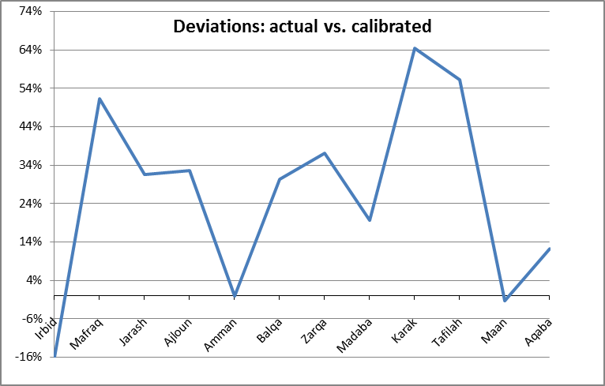

Note: X-axis represents relative distances from Amman (Irbid is the most
Northern and Aqaba the most southern governorate).

Chart 3: Transfers vs. Poverty rate Chart 4: Transfers vs. Unemployment rate
Amman
Mafraq
Amman
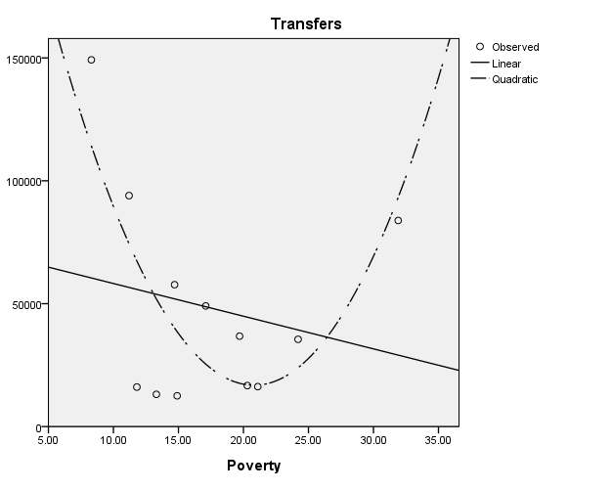
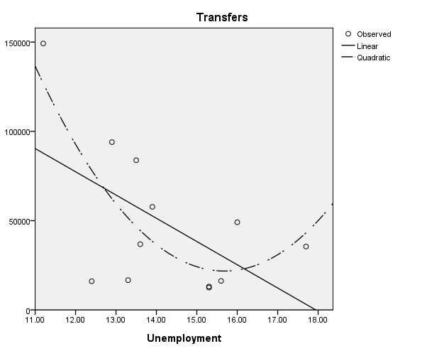
Ma’an
One reason why M1 is not able to allocate one-quarter of all transfers actually occurred may be because, paradoxically, transfers in 2011 correlated negatively with the rate of poverty and the rate of unemployment (see Charts 3 and 4).

The quadratic fitting curves in Charts 3 and 4 illustrate in more detail the explanation for the M-shape curve introduced above. The negative slope side of these curves represents the increasing distance away from Amman. However, beyond a threshold, the curves inflect and gain a positive slope. These positive inflections are associated with the remotely located governorates in relation to Amman (Mafraq on Chart 3 and Ma’an on Chart 4). This means that the central government changes the sign of its “criteria” beyond a certain distance threshold.

Chart 5: Transfers vs. Area
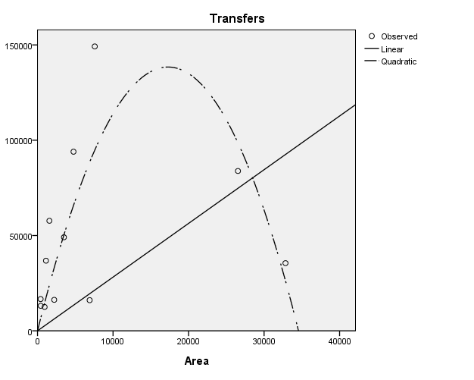

Amman

Mafraq

The threshold rule seems to be a common principle for Jordanian decision-makers and it is also applied to the size of governorates (sq. km.) (see Chart 5). Amounts transferred correlate positively with the size of the governorates up to a certain level, beyond which size is not compensated with additional funding.

Another reason for the problems M1 faced in adjusting to actual transfers may be simply that not all of the criteria included in the subset of criteria in the literature resemble the policy practice in Jordan. Actually, in the reduced model (F=67.339, R²=0.931, N=12), when running a linear regression analysis with all five criteria, only population (β=0.064*, std. error=0.007) and area (β=1.574*, std. error=0.433) are included as significant independent variables or parameters. Between these two criteria, population (standardized beta=0.819) plays a much more important role in transfer decisions than area (standardized beta=0.317). Population alone correlates 0.875 (Pearson Correlation) with transfers (see Chart 6).

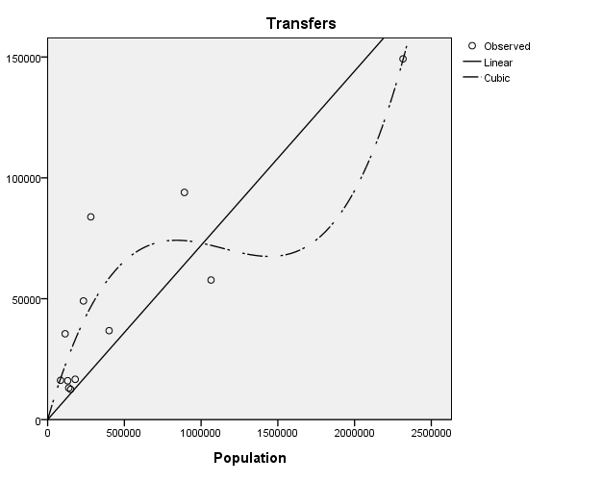
Chart 6: Transfers vs. Population

Amman

Zarqa
Mafraq

Irbid

The same linear model was built for 2009 and 2010 independently. While for 2009 none of the five criteria was found statistically significant, in 2010, population was a statistically significant transfer criterion. In combination with the results for 2011 these results suggest an increasing need to use objective criteria in intergovernmental transfers.

In summary, population and area were the two most important criteria used by decision-makers to allocate funds, and alone they explain most of the amounts transferred to governorates in 2011. However, there are still 7% of the total amounts transferred that cannot be explained by any of the parameters discussed so far. The next section offers a discussion of the policy implications for intergovernmental transfers of adopting combinations of parameters and/or coefficients that deviate from the modeled (current) government behavior. The parameter of density will be excluded from further analysis, given the statistical redundancy with the joint effect of population and area.

6. Policy Implications and Recommendations: An Exploratory Discussion of Trade-Offs
The previous section used different international transfer formula parameters to determine relevant parameters for Jordan. It then calibrated a statistical model using the selected parameters to uncover historical “rules” of transfer policy followed by Jordanian central authorities, which have been ambiguous and unclear. These “rules” are uncovered by the estimated coefficients and can be understood as current policy preferences regarding monetary transfers to each governorate. Finally, the estimated coefficients set a baseline for a discussion of the trade-offs associated with alternative transfer policy criteria (i.e., variations of the parameters and coefficients used in the baseline model).

The main methodological problem faced is that even though the relevant parameters have been selected there are infinite – both linear and non-linear – possible mathematical combinations for their coefficients. Consequently, the range of possible policy-making rationales and assumptions for the amounts transferred is equally very wide. Another difficulty with, and limitation of, the previous section is that it tries to capture policy practice using transfers data for one year only - 2011.

Population
Population weights found in international and Jordan-related literature range from 20% (MOPIC 2006) to 72% (MOMA 2012). This means that according to the statistical modeling developed in the previous section the Jordanian government has been, apparently, inflating the relevance of population for transfer calculation (87.5%). Chart 6 supports this finding, as the estimated model adjusts perfectly to the case of Amman Governorate – by far the most populated of all governorates.

A reduction of the population coefficient would, by definition, (i) benefit less populated governorates, such as Tafilah and Ma’an, and (ii) divert funds from more populated governorates such as Amman, Irbid and Zarqa, where 80% of the Jordanian population is concentrated.

Area
Area weights found in international and Jordan-related literature range from 5% (Ma 1997) to 32% (MOMA 2012). According to the statistical modeling developed in the previous section, the Jordanian government has been weighting the use of this parameter for transfer calculation at the lower end of the range suggested by the literature. However, if we take into consideration that the 5% found in the literature refers to India’s intergovernmental transfer formula, which uses a range of additional parameters, including infrastructure and tax revenue, there seems to be room for the Jordanian government to increase the weight of this parameter in the transfer formula. This is especially relevant considering that the highest poverty rates are found in the largest geographical governorates.

The assertion that there is margin to increase the area coefficient in the Jordanian transfer formula mirrors the previous remark, which suggested a reduction in the population coefficient. This is mainly because the largest governorates are also the governorates with the lowest population density (i.e., Ma’an and Mafraq).

Poverty and Unemployment
These two parameters were not found to be statistically significant when modeling transfer policy-making together with the parameters of population and area. This suggests that transfer policies have not been derived from the influence of these two parameters, which seems to be a paradox given the government’s main policy goal of combating extreme poverty. This paradox is even more evident with Charts 3 and 4 illustration of the negative correlation between amounts transferred and the degree of socio-economic severity associated with each parameter. Poverty and unemployment data could also be used to transform these parameters into indicators of deviation in relation to a certain threshold or national or local standard. In addition, this could help mitigate the issue of statistical “co-linearity” between these parameters and population and governorate area.

Given the apparent mismatch between policy goals to alleviate poverty and unemployment and transfer criteria in Jordan, there is room to argue that these two variables should be more heavily factored into the distribution of national resources across governorates. The current transfer regime is overwhelmingly urban-biased, in that population size trumps other socio-economic decision considerations, such as poverty and unemployment rates. This is particularly problematic for Jordan because per-capita costs of public services, which typically correlate negatively with population densities, coincide precisely with governorates with the highest poverty and unemployment rates.
7. Conclusions and Further Research
Decentralization, in general, and fiscal decentralization in particular, are still in nascent stages in Jordan. Much has been written and discussed the past fifteen years, but it remains very unclear what national strategy, if any, is effectively in place for the transfer of political power and financial resources from the central government in Amman to peripheral governorates. The ambiguity at the national level combined with the lack of technical and management capacity at the governorate level partly explain the absence of clear and stable rules for the calculation of amounts to be transferred to the local level.

First, not very different from the situation in other countries, there is no clear distinction between the political, fiscal and administrative aspects of decentralization and the sequence by which they should occur. Second, much more emphasis has been placed on aspects of administrative decentralization than on the transfer of political power and financial resources from the central government to governorates necessary to increase the degree of autonomy, capacity of subnational government, transparency and accountability. Many countries only deconcentrate to intermediate levels. However, in many of these cases, contrary to the municipality experience in Jordan, devolution effectively empowers lower administrative levels. Third, the little that has been written about the autonomy of governorates is not accompanied by an intergovernmental transfer system to allocate national revenues to subnational governments.

Decentralization is a long process and the implementation of a transfer formula should occur gradually through several trial and error phases. As Bird and Smart (2001) point out, “[I]ntergovernmental fiscal transfers constitute only part of a complex political, economic, administrative system. Their design, role, and effects can be understood only in the specific institutional context in which they operate” (p. 10). This article is the first attempt to address the multidimensional problem of regulating monetary transfers from the central government to governorates. Past practices are unclear and ambiguous and available data is insufficient vis-à-vis international experience. In addition, Jordanian decision-makers seem to prefer to continuously postpone the beginning of a process that could start simply and then progressively be adapted and gain complexity. In this scenario, all parties involved can better understand how formula-parameters behave and co-evolve.
Many political-economic factors underlie this reality and affect the likelihood of implementing the technical recommendations discussed in this research (Eaton et al. 2011). Jordan’s relatively small population, combined with its limited economic and natural resources, make control over taxation center of political and power dynamics. Unless a three level tax system - national, governorate, and municipal – is put in place it is unlikely that the central authorities will compromise the size of their national revenues by transferring their revenue-generating sources to local administrative levels.

There is no clear administrative or financial relationship between municipalities and governorates. It is essential to review current regulations governing the administration of municipalities and governorates in order to create a hierarchical administrative system capable of planning and delivering public services efficiently.

A new formula alone will not solve the deep regional imbalances, which require a bolder national approach to differences in economic opportunities across governorates. However, a new formula built upon Martinez-Vazquez and Boex’s (2002) principles, such as equity, transparency, needs and stability will help develop local infrastructure, thereby improving the well being of communities, supporting business development and encouraging civic participation.

The implementation of decentralization requires qualified human resources capable of dealing with the administrative and financial complexities resulting from new responsibilities delegated by the central government. It is crucial to design and implement a comprehensive capacity building national program for governorates and municipalities.

Jordan needs to find a comprehensive formula to fund its governorates. It also needs, however, to find an institutional framework to allow governorates to fund themselves either through local taxes, loans and/or a combination of the two. Considering all of the above, and only then, will King Abdullah II’s goals be achieved: (i) greater public participation in public sector policy-making and implementation, and (ii) effective social auditing of public sector performance.

Appendix 1
Detailed tasks of each administrative level

Administrative Level | Responsibility | Comments
1.Central Level
Cabinet (The Prime Minister and the Council of Ministers) | 1. To manage the affairs of the state, draw the general policy of the government and supervise the running of business in various government departments. | The Prime Minister is nominated by the King.
 | 2. The powers of the Council, the Prime Minister and ministers are determined by regulations issued by the Council of Ministers and go through constitutional channels to be ratified by the King.
 | 3. The Prime Minister exercises that which falls within his authority. He refers other matters to the Council of Ministers to deal with. The Council of Ministers may delegate any powers to the Prime Minister or any other minister.
Ministries-Ministers | 1. Each minister participates within the Council of Ministers to develop policies and manage its internal and external affairs. | Ministers are nominated by the Prime Minister and approved by the King.
 | 2. A minister holds the highest position in the administration of his ministry. He is responsible for overseeing its affairs and making crucial decisions. He is the main executor of resolutions related to staff in various departments connected to him, and and he follows up the administrative development therein, which includes the allocation of functions to the staff of a particular departments.
 | 3. A minister applies proposals that guarantee the smooth functioning of government; save time, money and effort; and guarantee public service delivery. He is the paymaster in his ministry and he represents the State within the limits of his authority and the authority of his ministry.
2. Local Level
Governorate-Governors | 1. He is at the head of administration of the governorate, and reports to the Minster of Interior. | Governors are appointed by a decree from the Council of Ministers at the recommendation of the Minster of Interior with Royal Assent.
 | 2. A governor supervises the local councils and holds regular meetings for the councils and the committees that he chairs.
 | 3. A governor takes the necessary measures to implement the decisions and recommendations issued by the local councils and committees. The Council of Ministers may delegate to the governor any of the powers of the Minister of the Interior. The security forces in the governorate are directly under his command, and he chairs the Government Property Committee in the Governorate.
 | 4. A governor works in coordination with the relevant authorities, in accordance with laws and regulations in force, to provide public services in the governorate and follow up their development, e.g.
 | - Opening, paving and maintaining roads (main, rural and agricultural)
 | - Providing drinking water and sewage system.
 | - Taking the necessary measures to maintain and protect environment.
 | - Providing health service and social care.
 | - Providing electricity, post and communication services.
 | - Organizing and protecting public utilities, following up on the general needs of education, human resources, equipment- establish libraries, public markets, provides civil defense service, protect forests and other functions.
 | 5. The governor is the paymaster from funds allocated to the governorate and which he is authorized in writing to spend from, he follows up the execution of the projects listed in the budget.
 | 6. The governor follows the execution of the decisions of the Executive Council with the competent parties according to the priorities that he decides and available capabilities.
Executive Council | 1. To determine the projects that it deems should be executed in the governorate during the financial year, the priorities and cost of these projects. The governor submits the decisions to the competent departments to include in the general budget. | Chaired by the Governor, represents the head of line ministries at the governorate level.
 | 2. The Executive Council also reviews the general conditions in the governorate and discusses matter related to public services. The governor follows up the execution of the Executive Council decisions.
Consultative Council | 1. A Consultative Council is formed in each governorate, chaired by the governor and have a membership of twenty-five persons appointed for a term of three years by the Minister of Interior at the recommendation of the governor. In forming the Consultative Council, care is taken to include various parties like municipalities, chambers of commerce and industry, banks, charities cooperatives, farmers, doctors and other professionals.
 | 2. The Consultative Council has the task of studying the affairs of the governorate and issue the relevant recommendations, including giving an opinion on the governorate annual budget before being ratified by the Executive Council.
Municipal Council | 1. Town and street planning: Town planning; street opening, modification, pavement and cancellation and determination of street width and straightness; street sidewalk construction; street maintenance, sanitation, beautification and tree planting; naming or numbering of streets and numbering of their buildings; prevention of street encroachments; monitor open areas adjacent to them and instruct their owners to erect walls around them.
 | 2. Building Licenses: Monitor building construction, demolition, reshaping and installation of electrical lifts; issue licenses to carry out these operations; determine the building location, layout and its area in ratio to the land area on which it is planned to be constructed; ensure satisfaction of sanitary conditions and electricity.
 | 3. Sewage system: Drain storm water, construct, manage and monitor public toilets and sanitary utilities.
 | 4. Public markets: Organize and establish public markets and designate the types of products to be sold in each or forbid the sale of such products outside.
 | 5. Craft and industries: Organize craft and industries and designate quarters for each type; monitor stores and activities that cause disturbances or pose health hazards.
 | 6. Road transportation vehicles and means: Construct, designate, organize and monitor road vehicle parking lots within the boundaries of the municipalities.
 | 7. Public places: Monitor restaurants, cafes, clubs, pubs, discotheques, playgrounds, theatres, cinemas and other recreational areas. Organize, determine opening and closing times of these facilities, impose and levy fees on their ticket sales.
 | 8. Parks: Construct yards, gardens, parks, and swimming areas.
 | 9. Extinguishers and fire prevention: Take precautionary measures to prevent fires, monitor fuel and flammable materials, regulate their sale and storage, possess and maintain extinguishers.
 | 10. Flood precautions: Take precautions to prevent damages from floods and storm water.
 | 11. Rescue disaster victims: Rescue victims of fires, floods, earthquakes and other general disasters; collect and distribute donations.
 | 12. Cultural and athletic institutions: Establish and monitor museums, public libraries and schools as well as cultural, athletic, social and musical clubs.
 | 13. Food: Monitor bread, meat, fish, fruit, vegetables and other foodstuff and take the necessary action to prevent cheating; destroy spoiled food, and fix prices and fight high costs.
 | 14. Inspection of slaughtered animals and establishment of slaughterhouses: Examine animals and poultry ready for slaughtering; take necessary action to avoid their infection; designate areas for sale, monitor slaughtering operations, dispose of remains and establish slaughterhouses.
 | 15. Cleaning services: Collect garbage, trash and waste from houses and public stores; transport and destroy such waste and regulate the operation.
 | 16. Health control: Monitor houses and other stores to ensure that they dispose of their waste properly, to ensure that equipment is sanitary. Take necessary precautions to prevent ousted mosquitoes and other insects from returning.
 | 17. Public health: Take all necessary precautions and procedures to maintain public health and prevent the spread of epidemics among people.
 | 18. Cemeteries: Establish, cancel and monitor cemeteries and designate their locations and specifications; transport and bury the deceased; regulate funerals and maintain the sanctity of the graves.
 | 19. Hazard prevention: Take necessary precautions to protect people and property and prevent damages and harmful effects resulting from any activity mentioned in this article.
 | 20. Vendors and kiosks: Monitor and regulate vendors, mobile photographers, porters, shoe polishers and kiosks.
 | 21. Advertisements: License and monitor signs and advertisements.
 | 22. Demolition of buildings likely to collapse: Demolish buildings which are likely to collapse, which are harmful to public health and safety, or which emanate harmful odors, after warning their owner or occupant.
 | 23. Platform scales: Weigh items sold wholesale outside shops and stores.
 | 24. Leftover roads: Sell or utilize leftovers of roads.
 | 25. Dogs: Monitor dogs, exterminate stray dogs, take preventive measures against their hazards, and issue licenses.
 | 26. Sumpters (Pack animals): Monitor animals used for carrying or towing, assign markets for selling animals and livestock and forbid their sale outside such markets.
 | 27. Budget, closing account and cadre: Approve the annual budget, the closing account and cadre before sending them for endorsement verification.
 | 28. Disposal of municipality property: Manage municipality property and monies; construct the required buildings therein; lease, mortgage, sell and buy others under the terms of this law; accept grants, wills and donations.
 | 29. Other functions: Carry out any other work required by it under this law or any other legislation in effect in the Kingdom.
Source: MOMA (2007).

References

Allers, M. and Ishemoi, L. 2011. Do Formulas Reduce Political Influence on Intergovernmental Grants? Evidence from Tanzania. The Journal of Development Studies 47(12): 1781-1797.
Anwar, S., and Shen, C. 2006. Fine Tuning the Intergovernmental Transfer System to Achieve a Harmonious Society and a Level Playing Field for Regional Development in China. The World Bank, Washington: DC.
Bahl, R. 2000. Intergovernmental Transfers in Developing and Transition Countries: Principles and Practice. Urban & Local Government: Municipal Finance, Background Series. The World Bank, Washington: DC.
Baker, K., and Camm, J. 2005. On the Use of Integer Programming versus Evolutionary Solver in Spreadsheet Optimization. Transactions on Education. 5(3): 1–7.
Banful, A. 2011. Do formula-based intergovernmental transfer mechanisms eliminate politically motivated targeting? Evidence from Ghana. Journal of Development Economics 96(2): 380-390.
Bird, R., and Smart, M. 2001. Intergovernmental Fiscal Transfers: Some Lessons from International Experience. Symposium on Intergovernmental Transfers in Asian Countries: Issues and Practices, Asian Tax and Public Policy Program. Hitosubashi University, Tokyo, Japan.
Caldeira, E. 2012. Does the System of Allocation of Intergovernmental Transfers in Senegal Eliminate Politically Motivated Targeting? Journal of African Economies, 21(2): 167-191
Department of Statistics (DOS). 2010. Jordan in Figures. Government of Jordan.
Eaton, K., Kaiser, K., and Smoke, P. 2011. The Political Economy of Decentralization Reforms: Implications for Aid Effectiveness. World Bank. Available at https://openknowledge.worldbank.org/handle/10986/2336
El Mensi, M. and Romeo, L. 2009. Policy and Technical Advisory Services to the Inter-Ministerial Technical Committee on Decentralization in Jordan. United Nations Development Program (UNDP), New York: NY.
Falleti, T. 2005. A Sequential Theory of Decentralization: Latin American Cases in Comparative Perspective. American Political Sciences Review. 99(3): 327-346.
Jordan Resource Transfer Pool and Allocation to Municipalities Bulletin No. (01).
Kammeier, D. 2010. Capacity Building for Decentralization in Jordan: Focus on Governorate LDU. United Nation Development Program (UNDP), New York: NY.
Leading Point Management Advisory. 2011. LED Strategy Framework: Local Economic Development Strategy, Investment Planning, and Institutional Building Project. Regional and Local Development Project (RLDP). Ministry of Municipal Affairs of the Government of Jordan.
LGDK-Denmark. 2008. Decentralization and Women’s Participation in Jordan Project: Vision for Decentralization in Jordan. Government of Jordan.
LGDK-Denmark. 2011. Local Government Performance Assessment System (LGPAS), for municipalities and governorates in Jordan. Ministry of Municipal Affairs of the Government of Jordan.
Ma. 1997. Intergovernmental Fiscal Transfer: A Comparison of Nine Countries. The World Bank, Washington: DC.
Martinez-Vazquez, J. and Boex, J. 2002. The Design of Equalization Grants: Theory and Application. World Bank Institute, Washington, D.C.
Ministry of Interior (MOI). 2005. Administrative Formation Law 37/1995. Government of Jordan.
________________(MOI). 2010. The Local Council Draft Law. Government of Jordan.
Ministry of Municipal Affairs (MOMA). 2005. Power Point Presentation: The Intergovernmental Transfers committee's Result. Government of Jordan.
_______________________________. 2011. Jordan Municipal Law 13/2013. Government of Jordan.
_______________________________. 2010. Regional and Local development Project: Revision of the Current Formula. Government of Jordan.
Ministry of Planning and International Cooperation (MOPIC). 2006. Regional and Local development Project: Assessment and Design of Municipal Finance Institutions and Instruments & Strengthening the Capacity of the Ministry of Municipal Affairs, and the Cities and Villages Development Bank. Phase 2 Report. Government of Jordan.
_________________________________________________. 2010. Implementation Enablement Program for Decentralization. Government of Jordan.
Royal Committee for Regionalization. 2005. Regionalization Draft Law. Government of Jordan.
Sen, T. and Trebesch, C. 2004. The Use of Socio-Economic Criteria for Intergovernmental Transfers: The case of India. Working Papers 04/10, National Institute of Public Finance and Policy.
SOFRECO. 2010. Building Development Capacities of Jordanian Municipalities: Baladiaty. Report for the European Union-Delegation-Jordan: EuropeAid/129887/C/SER/JO.
Sylvain, B. 2002. Decentralization and Reform in Africa. Kluwer Academic Publisher, New York: NY.
United Nations Development Program (UNDP). 2005. Fiscal Decentralization in Transition Economies: Case Studies from the Balkans and Caucasus. UNDP, New York: NY.
______________________________________. 2009. The Future of Decentralization in Jordan. UNDP, New York: NY.
Yilmaz, S. and Guner, A. 2013. Local Government Discretion and Accountability in Turkey. Public Administration Development. 33: 125–142.

His Majesty King Abdullah II’s website http://www.kingabdullah.jo/press_room/speechpage.php/ [Accessed on 11.10.2011].
Jordan has approximately 6.133 million inhabitants (Jordanian Department of Statistics, 2010) distributed across twelve different Governorates headed by appointed governors. Governorates are administratively sub-divided into Municipalities, totaling 93 across the country.
Most recent information available.
Source: www.imf.org/external/pubs/ft/gfs/yearbook/2008/gfsy08.pdf [Accessed on 11.10.11].
Source: http://www.mma.gov.jo/MunicipalDB/Criteria.aspx [Accessed on 11.10.12].
Capital expenditures are the monetary amounts transferred from the central government to the governorate level to implement projects in social services sector (e.g., education, health, youth, environment), productivity sector (agriculture, tourism, industry) and infrastructure sector (water, sewage, transportations, public works, electricity).
Intergovernmental capital transfers data to prior 2009 were not available.
Data are in current U.S. dollars prices: $21.9 billion (2008), $23.8 billion (2009), $26.4 billion (2010), $29.2 billion (2011 est.). Source: IMF at http://www.imf.org/external/pubs/ft/weo/2012/01/index.htm [Accessed 05.16.2012].
Central Bank of Jordan website. http://statisticaldb.cbj.gov.jo/index?action=level4&page_no=0. [Accessed 05.28.2012]
While some of the countries listed may also factor fiscal capacity in their transfers’ formula, our analysis is centered around needs-based indicators.
The property tax is the only tax collected at the municipal level (not at the governorate level) according to the Property Tax Law No. 11 of the year 1954.
Most recent information available.
These 23.11% correspond to the 134,193 thousands of dinars (i.e., difference between totals in Table 6) not allocated to any Governorate by M1 when minimizing the sum of absolute deviations between actual and adjusted transfers (153,559 thousands of dinars).
The minimization approach to M1 imposed the constraint: all coefficients are positive.
Contrary to the cases of poverty and unemployment, the curve estimation for area does not include the coefficient constant, since a hypothetical governorate of size zero would not exist and, thus, would not receive transfers.
The coefficient constant is not included in this model since a hypothetical governorate characterized by zeros in all independent variables would obviously not receive any funds from the central government. Significance at 1% is denoted by *.
The degree of randomness; i.e., the variability of criteria from one year to the other, seems to be such that a model ran with the years 2009, 2010 and 2011 together did not produce statistical significant results.

